**Liouville's Constant**

Liouville 's constant, sometimes also called Liouville's number, is the real number defined by

|  |
| --- |
| L=sum_(n=1)^infty10^(-n!)=0.110001000000000000000001... |

Liouville's constant is a decimal fraction with a 1 in each decimal place corresponding to a factorial n! and zeros everywhere else. Liouville constructed an infinite class of transcendental numbers using continued fractions, but the above number was the first decimal constant to be proven transcendental. However, Cantor subsequently proved that "almost all" real numbers are in fact transcendental.

Liouville's constant nearly satisfies

|  |
| --- |
| 10x^6-75x^3-190x+21=0, |

which has solution 0.1100009999..., but plugging x=L into this equation gives -0.0000000059... instead of 0.

## The existence of Liouville numbers (Liouville's constant)

Here we show that Liouville numbers exist by exhibiting a construction that produces such numbers.

For any integer *b* ≥ 2, and any sequence of integers (*a*1, *a*2, …, ), such that *ak* ∈ {0, 1, 2, …, *b* − 1} ∀*k* ∈ {1, 2, 3, …} and there are infinitely many k with *ak* ≠ 0, define the number

{\displaystyle x=\sum \_{k=1}^{\infty }{\frac {a\_{k}}{b^{k!}}}}

In the special case when *b* = 10, and *ak* = 1, ∀*k*, the resulting number *x* is called **Liouville's constant:**

*L* = 0.**11**000**1**00000000000000000**1**0000000000000000000000000000000000000000000000000000000000000000000000000000000000000000000000**1**...

It follows from the definition of *x* that its base-*b* representation is

{\displaystyle x=\left(0.a\_{1}a\_{2}000a\_{3}00000000000000000a\_{4}0000000000000000000000000000000000000000000000000000000000000000000000000000000000000000000000a\_{5}\ldots \right)\_{b}\;}

where the *n*th term is separated from the next term by (*nn*! − 1) zeros.

Since this base-*b* representation is non-repeating it follows that *x* cannot be rational. Therefore, for any rational number *p*/*q*, we have |*x* − *p*/*q* | > 0.

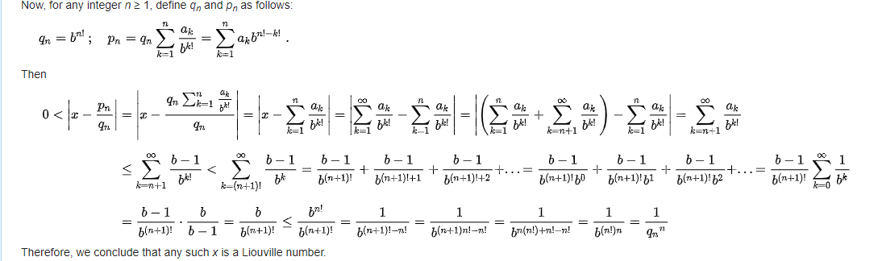

{\displaystyle q\_{n}=b^{n!}\,;\quad p\_{n}=q\_{n}\sum \_{k=1}^{n}{\frac {a\_{k}}{b^{k!}}}=\sum \_{k=1}^{n}{a\_{k}}{b^{n!-k!}}\;.}